**>> As per Veraval bank complain case**

* Issue check

# DAY_OPEN_DEBIT_CHARGE

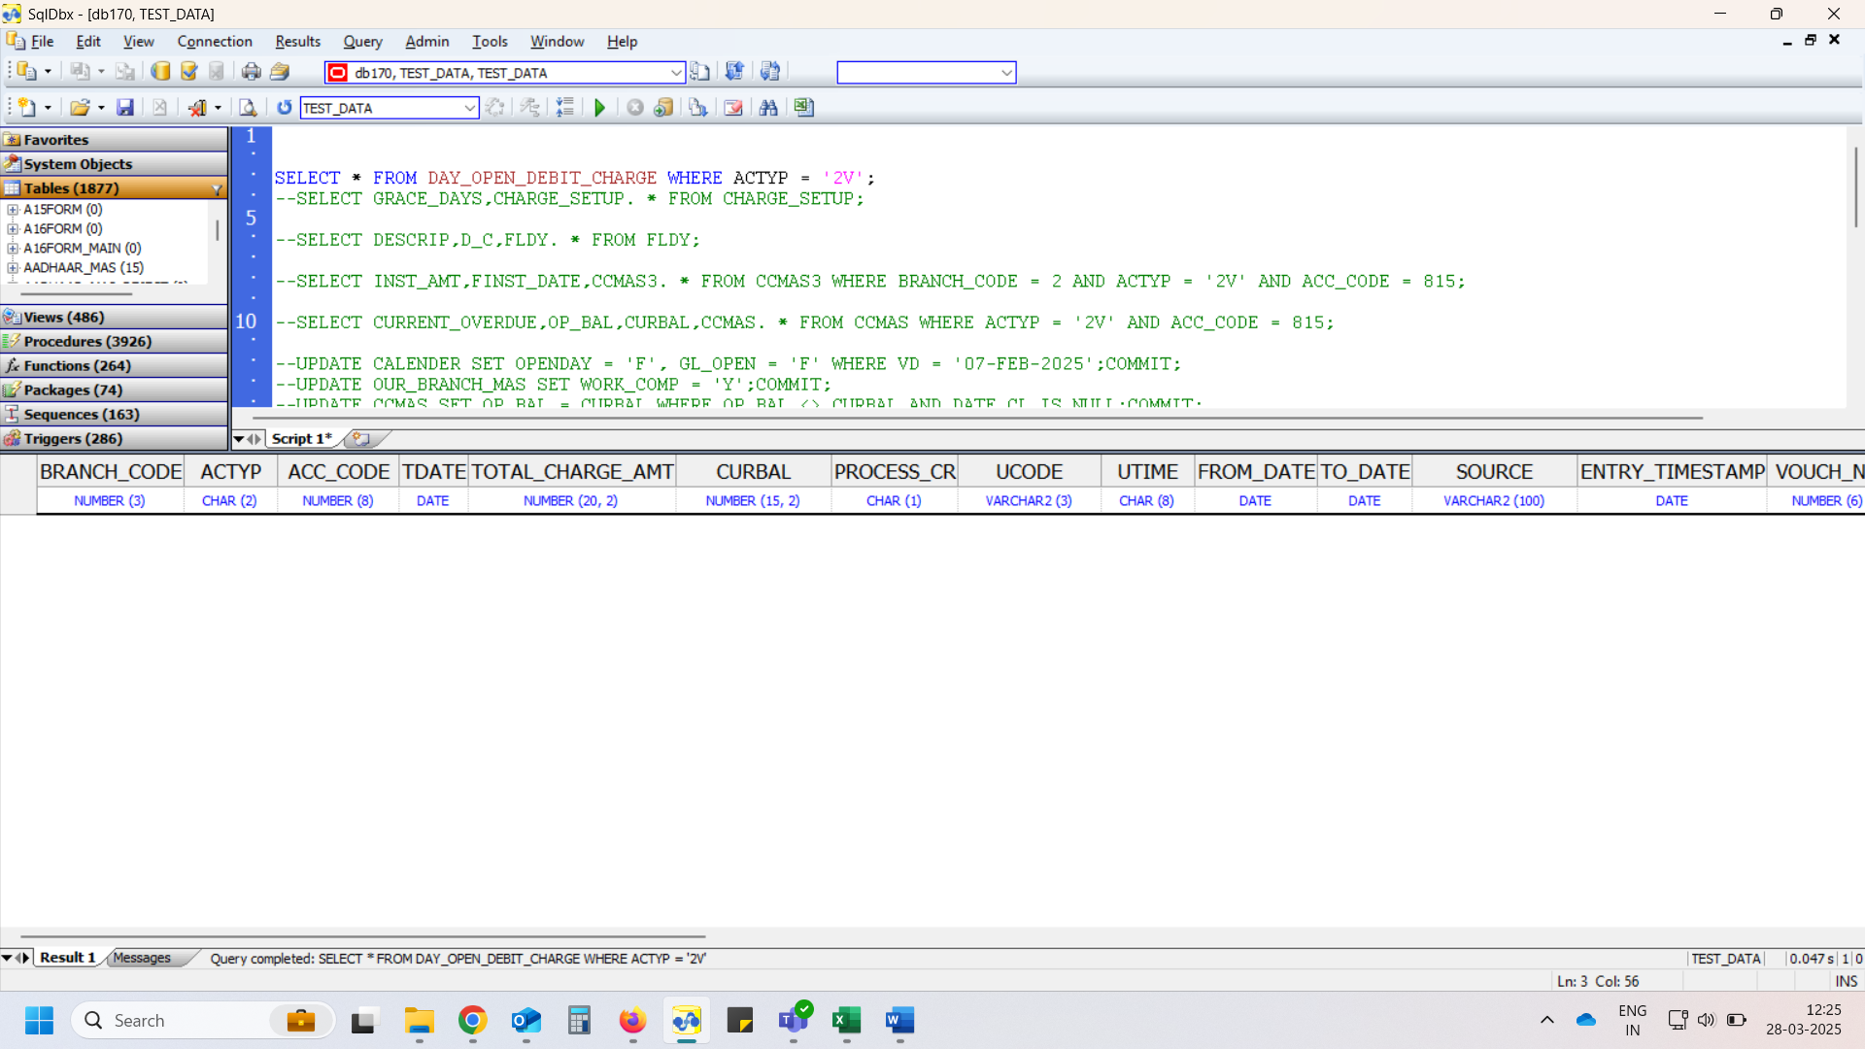

# CHARGE_SETUP

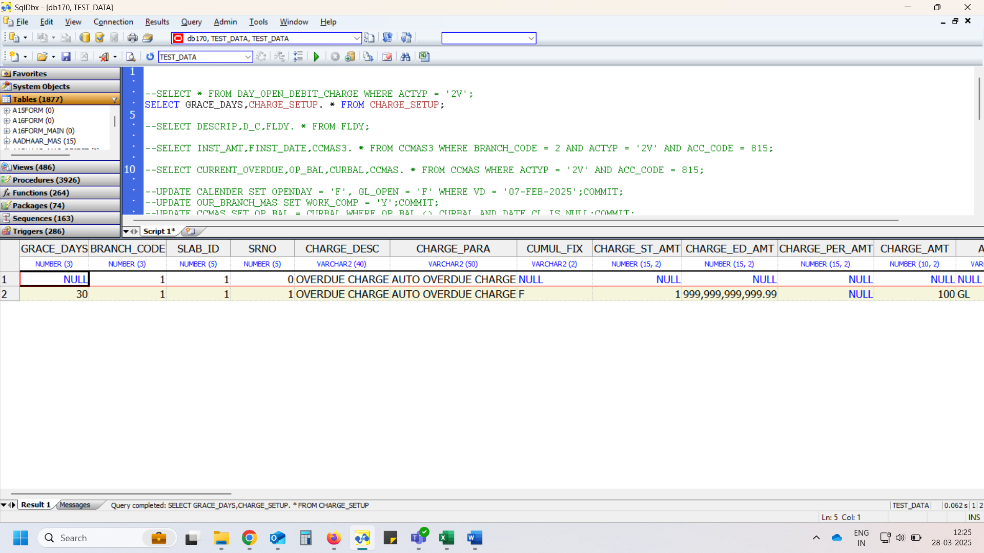

# CCMAS3

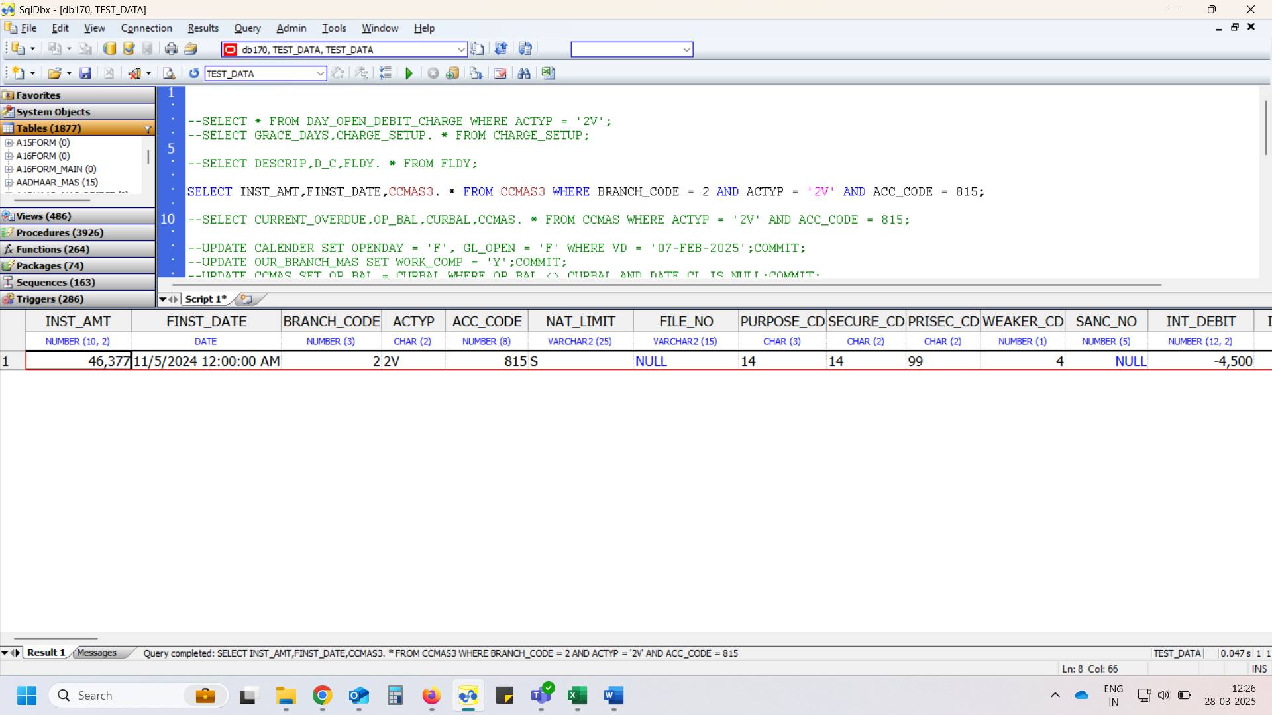

# CCMAS

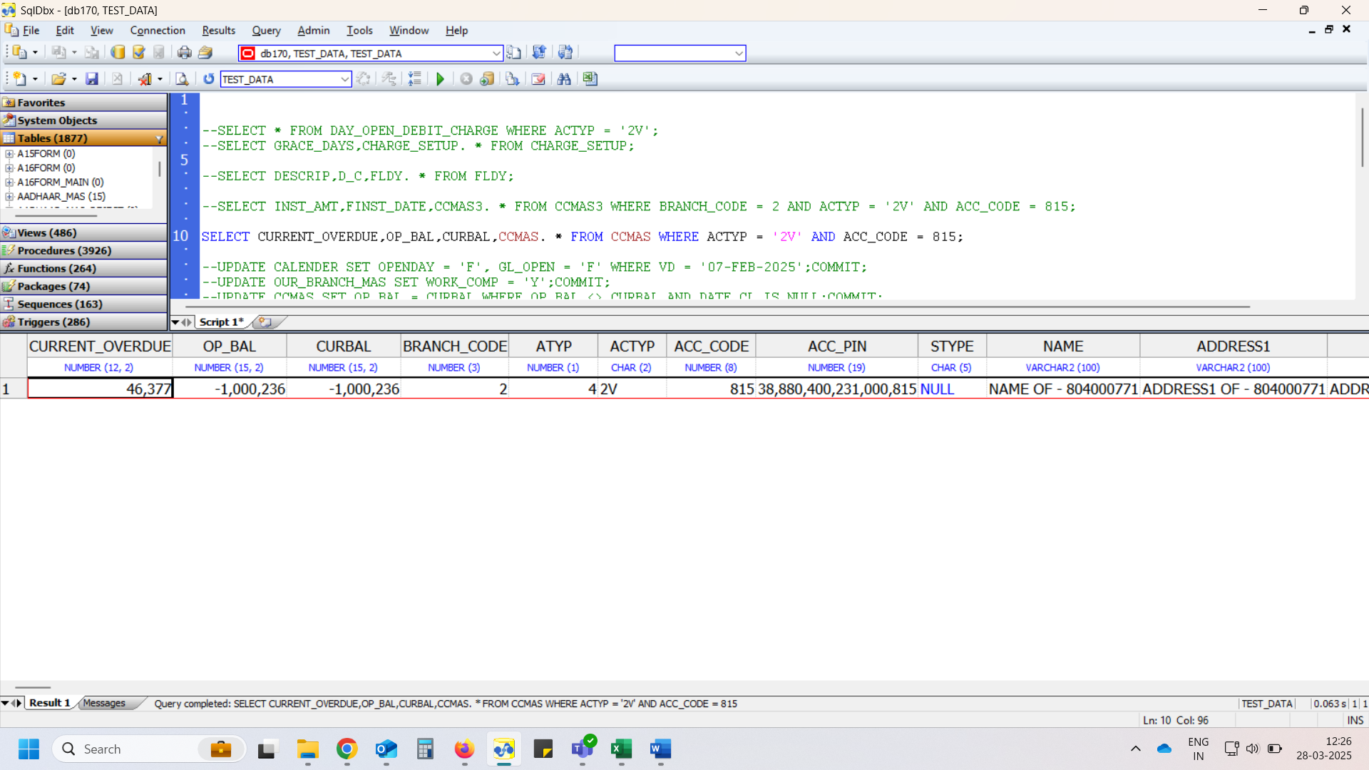

# Day Open

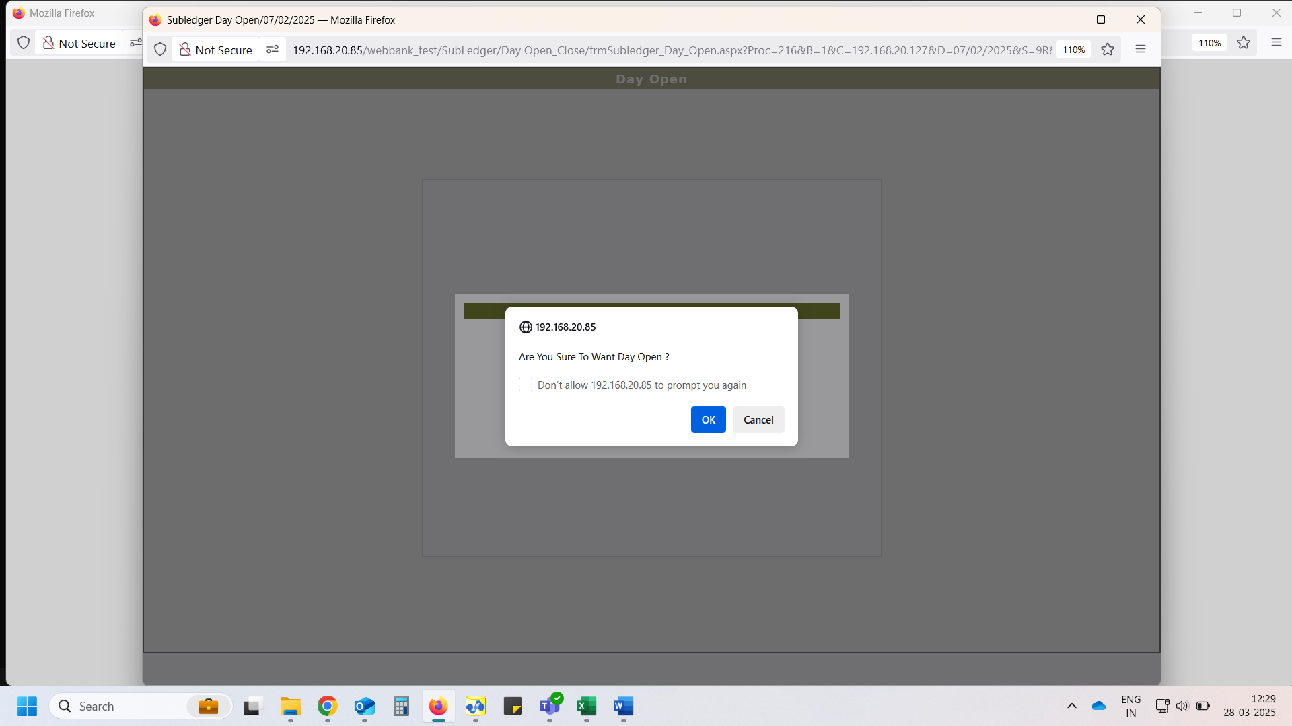

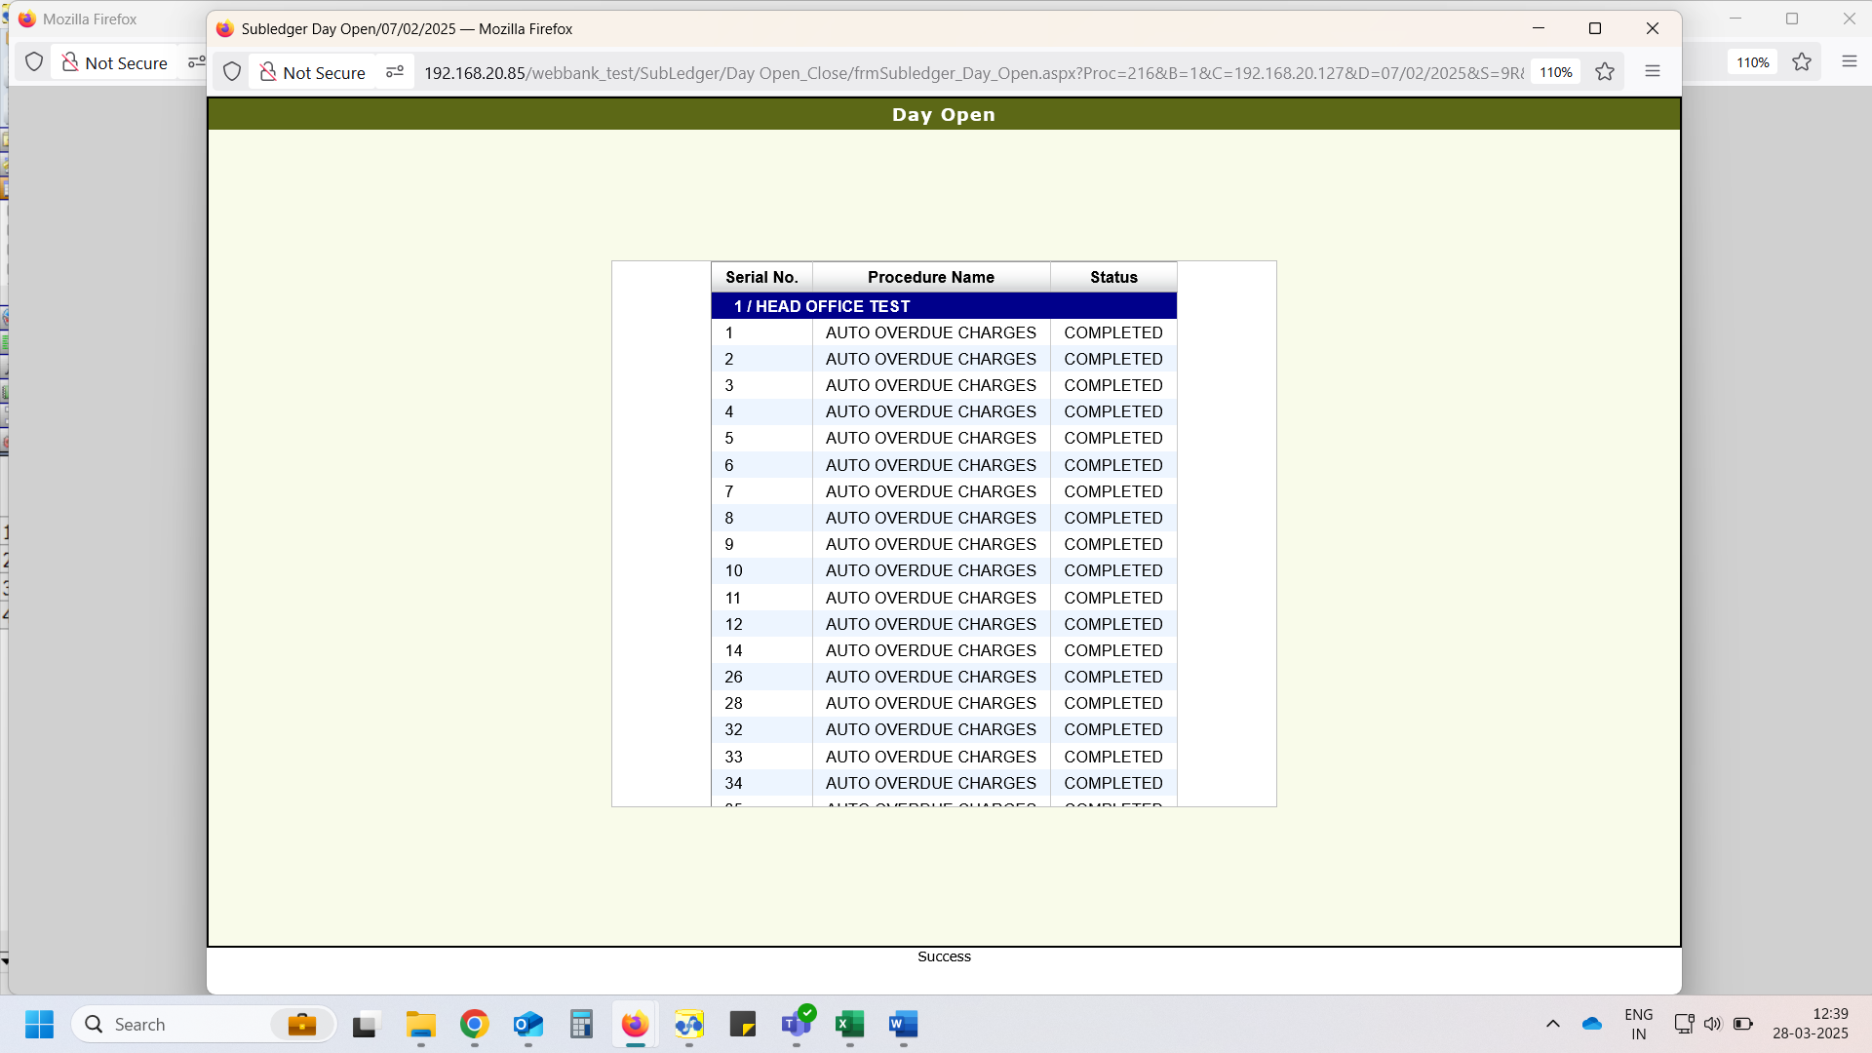

# FLDY – Charges debited, and it was issue

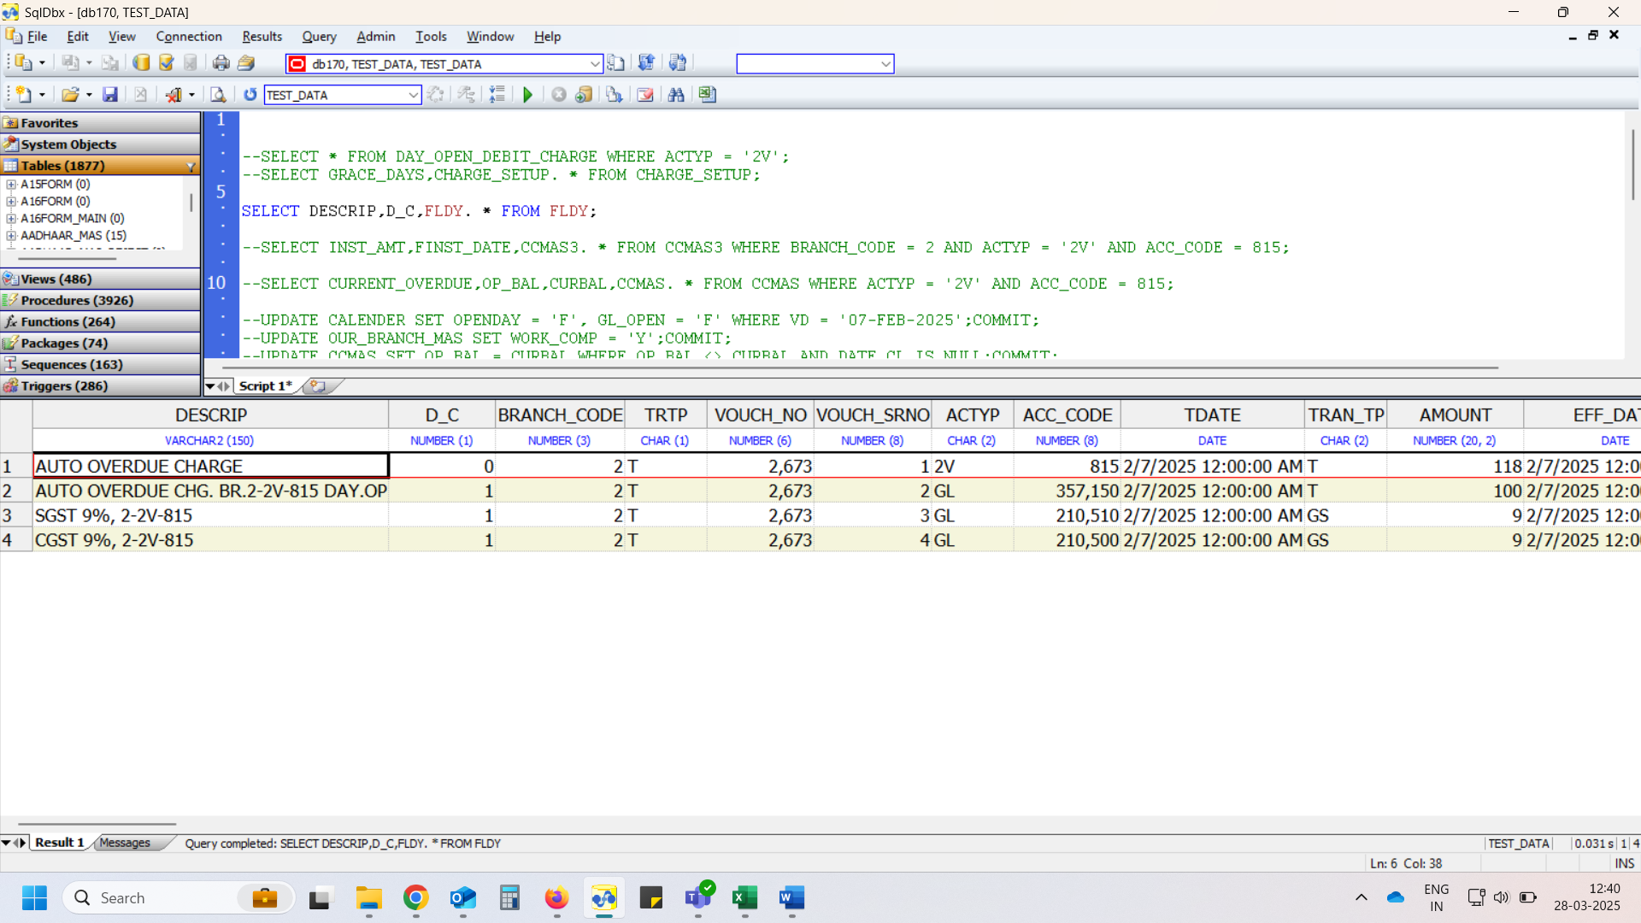

# DAY_OPEN_DEBIT_CHARGE

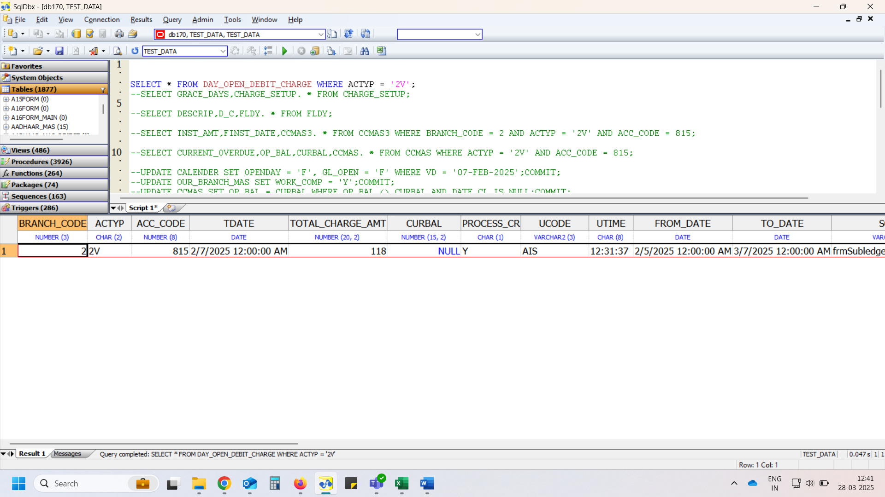

* Same scenario check after issue resolved

# DAY_OPEN_DEBIT_CHARGE

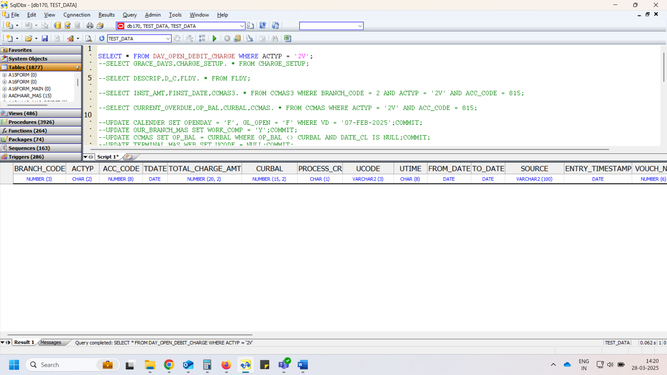

# CHARGE_SETUP

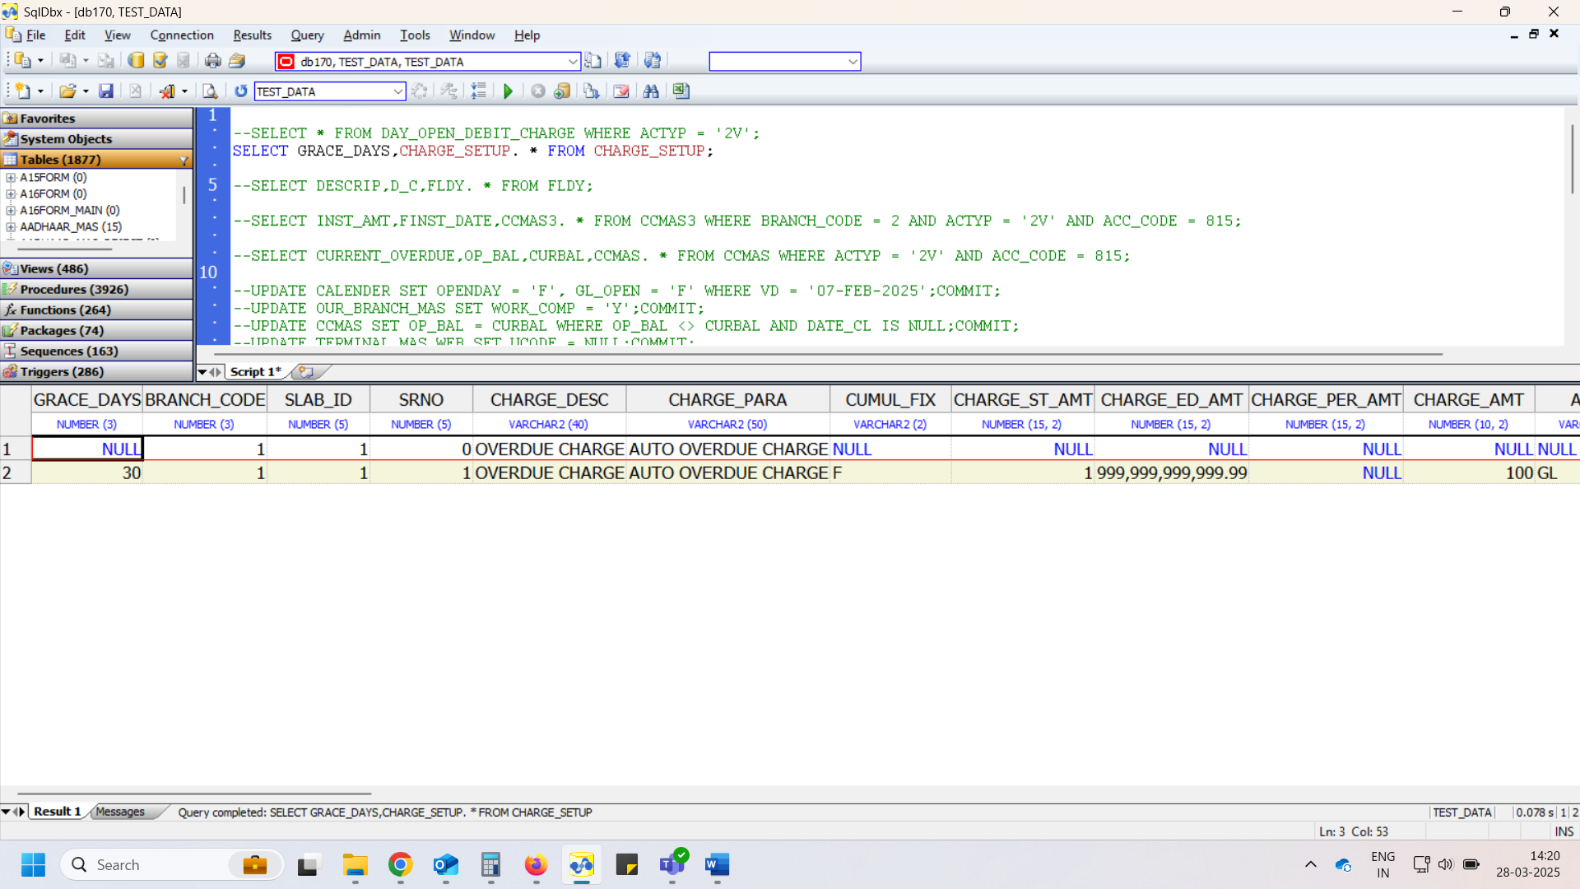

# CCMAS3

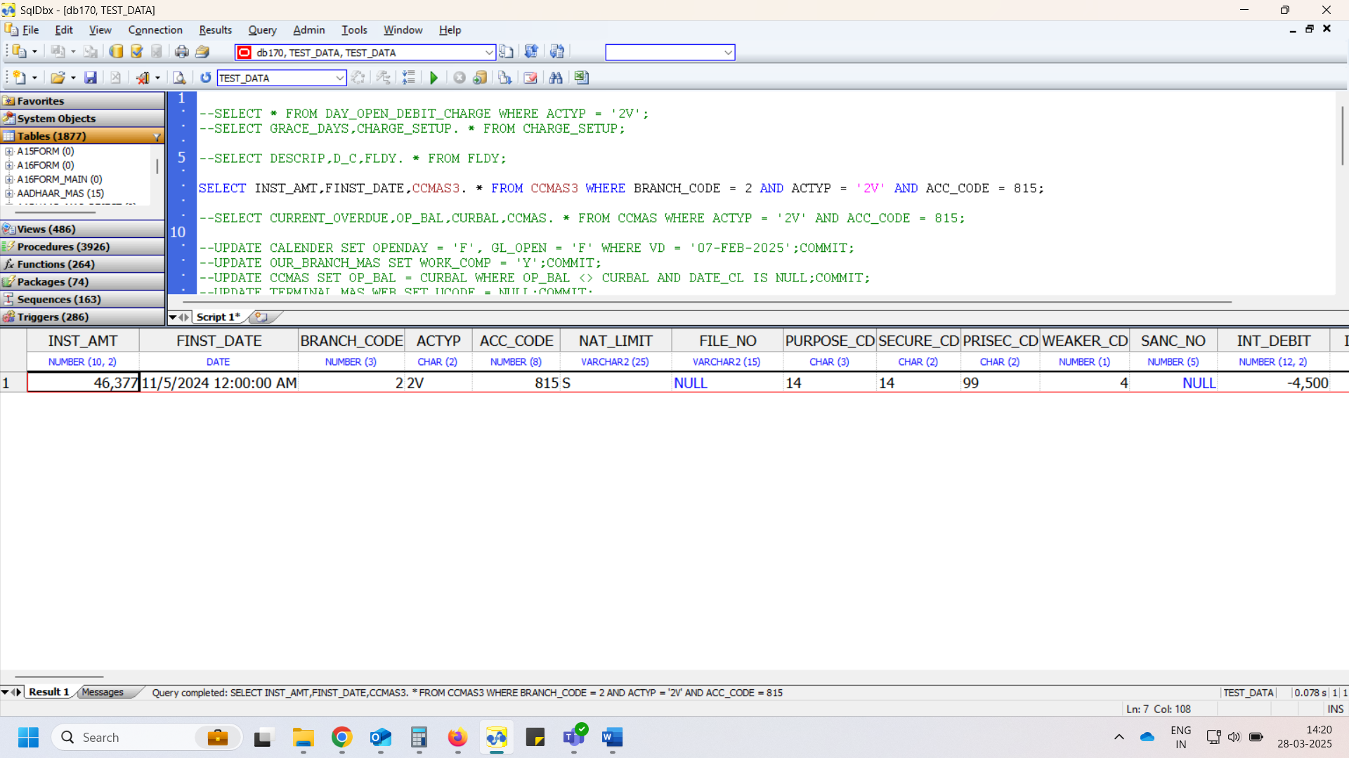

# CCMAS

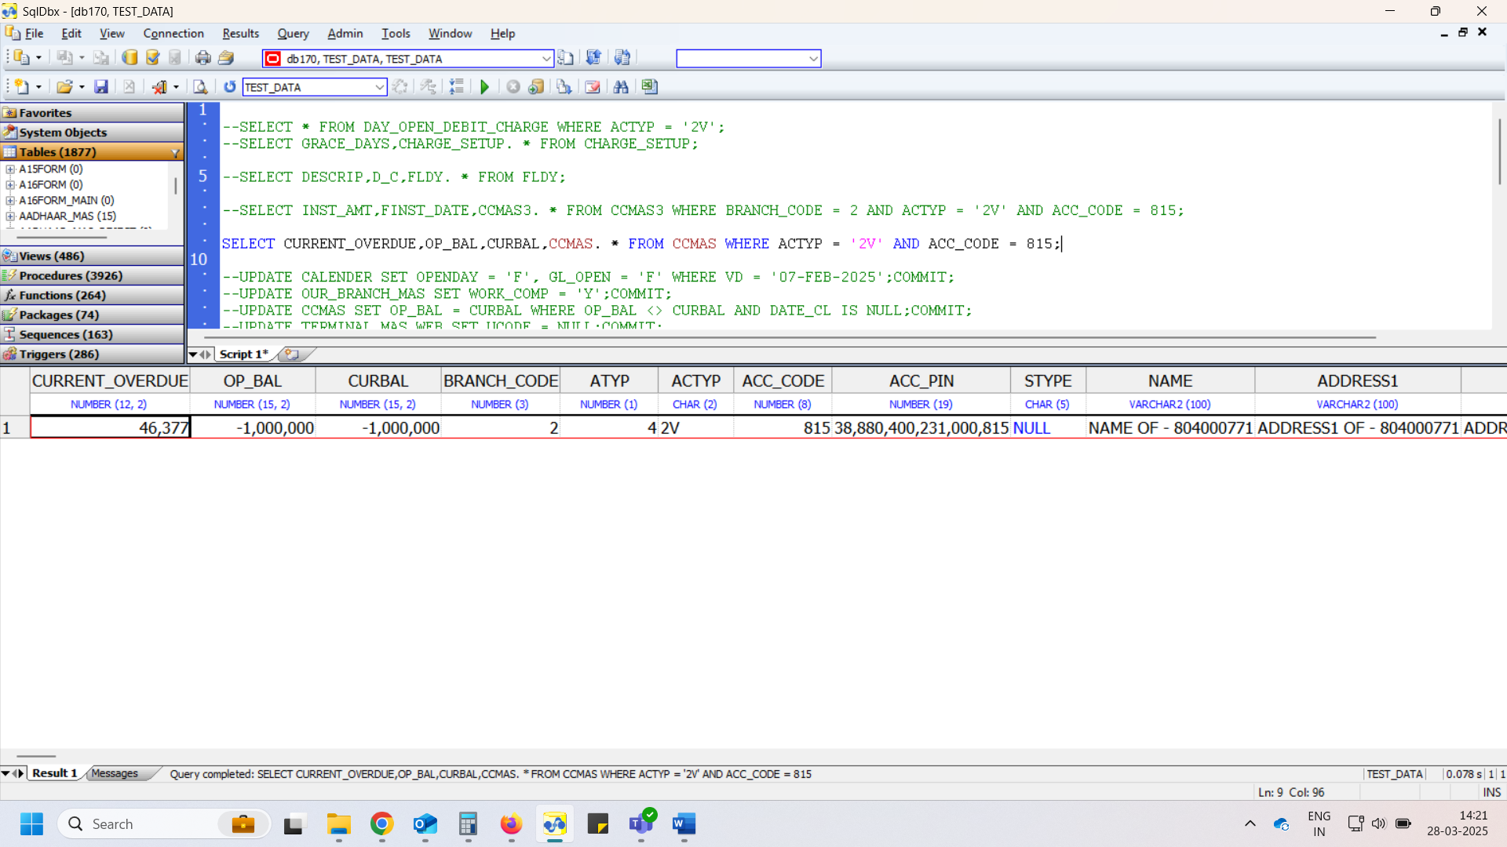

# Day Open

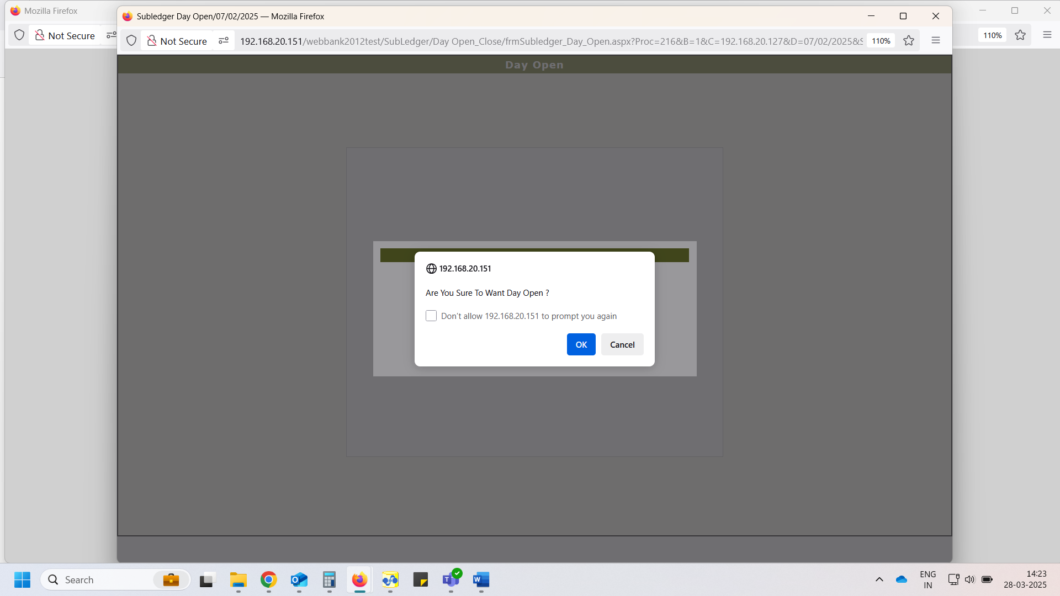

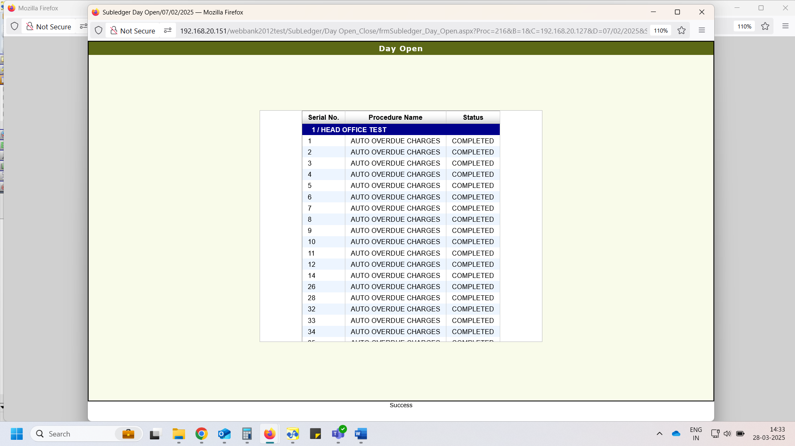

# DAY_OPEN_DEBIT_CHARGE – For this scenario entry does not insert and its proper now

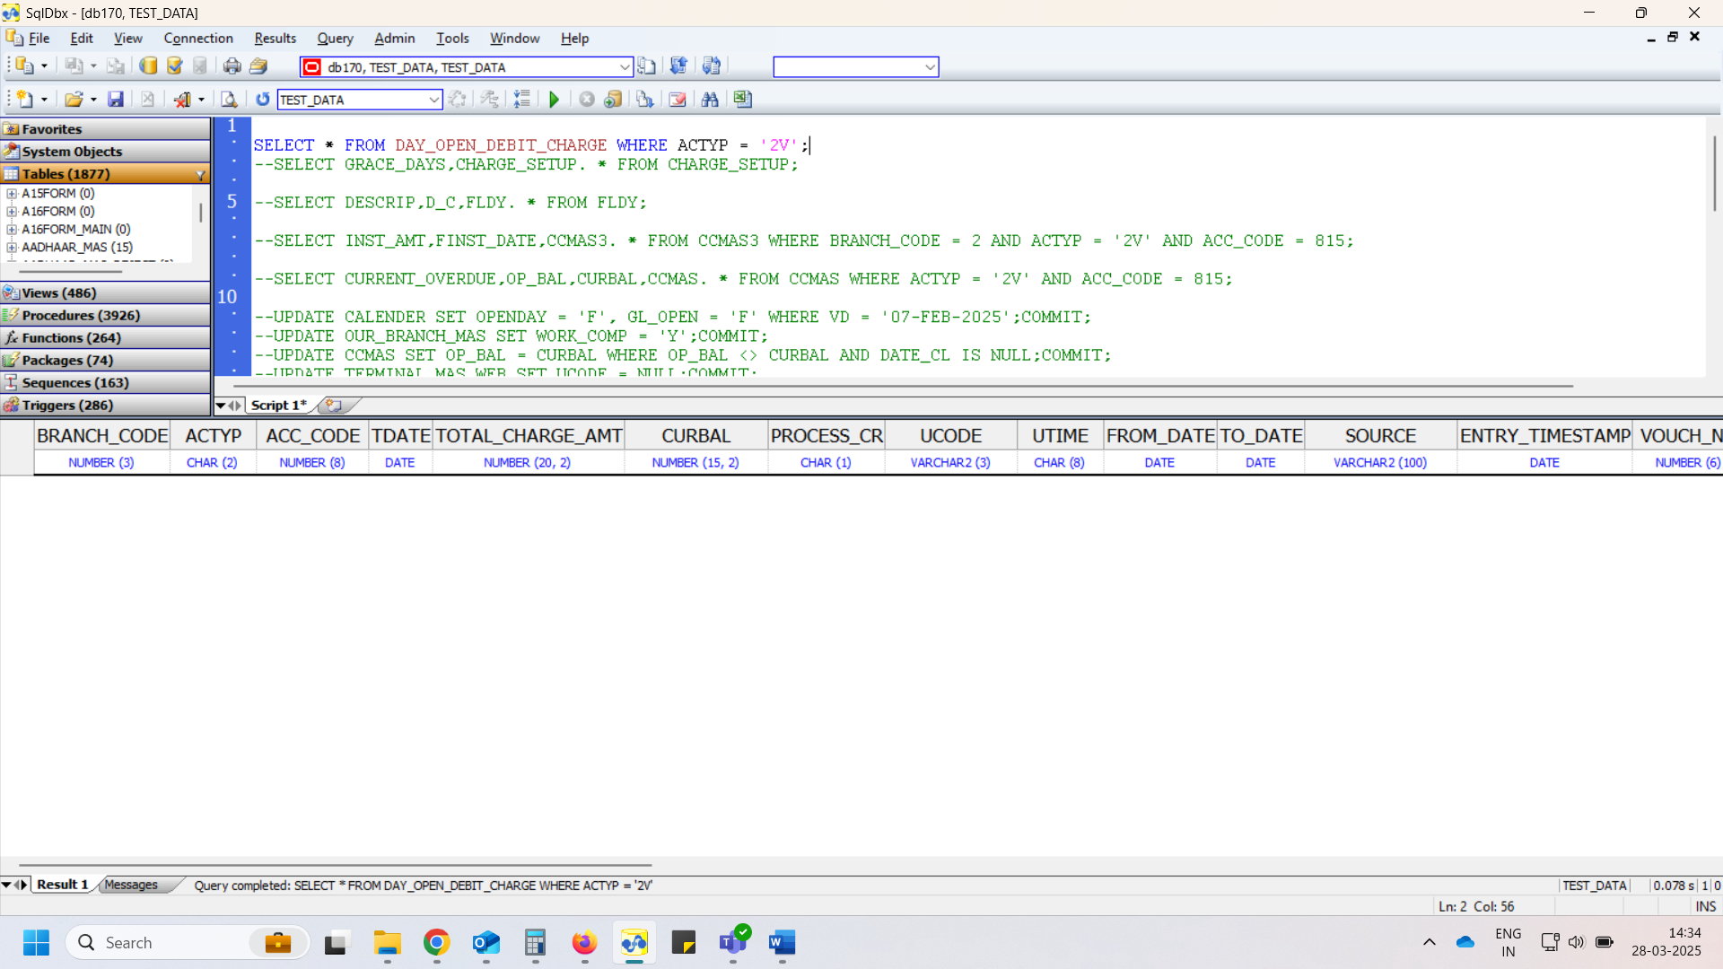

# FLDY – Charges does not debit for this scenario, and it is proper now.

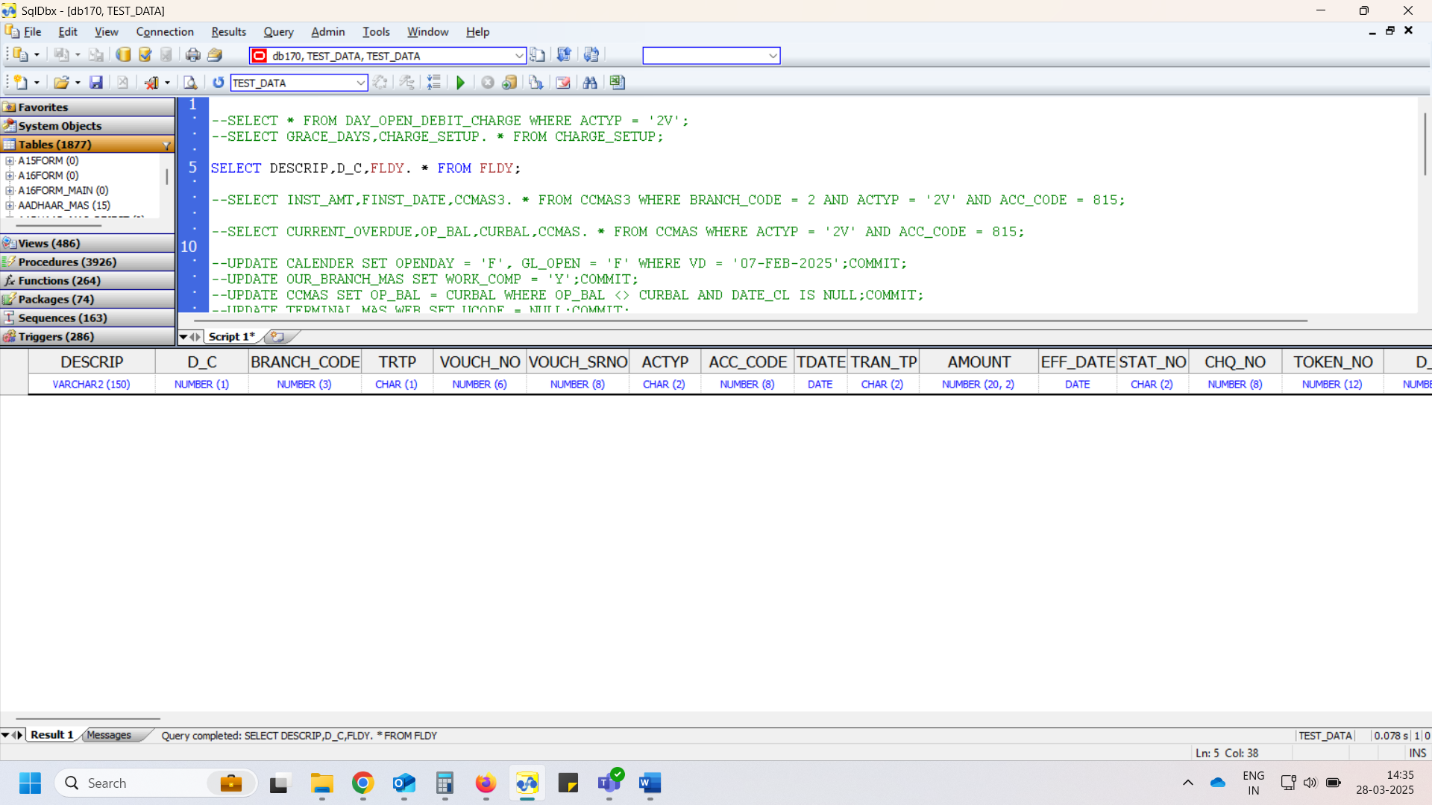

**>> As per Unjha Nagarik bank complain case**

* Issue Check

# DAY_OPEN_DEBIT_CHARGE

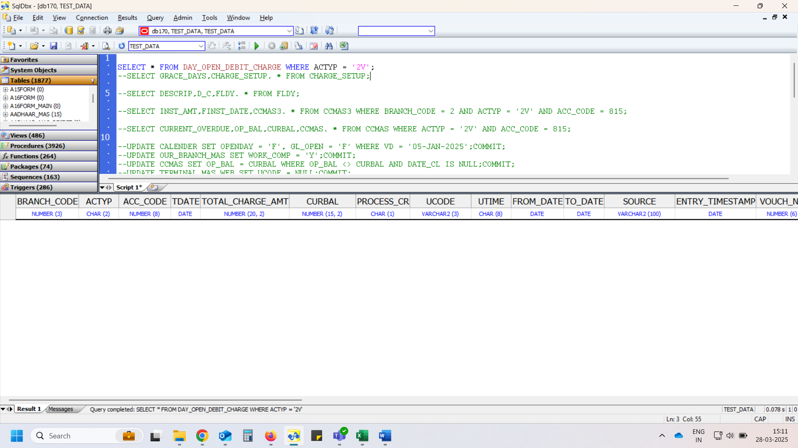

# CHARGE_SETUP

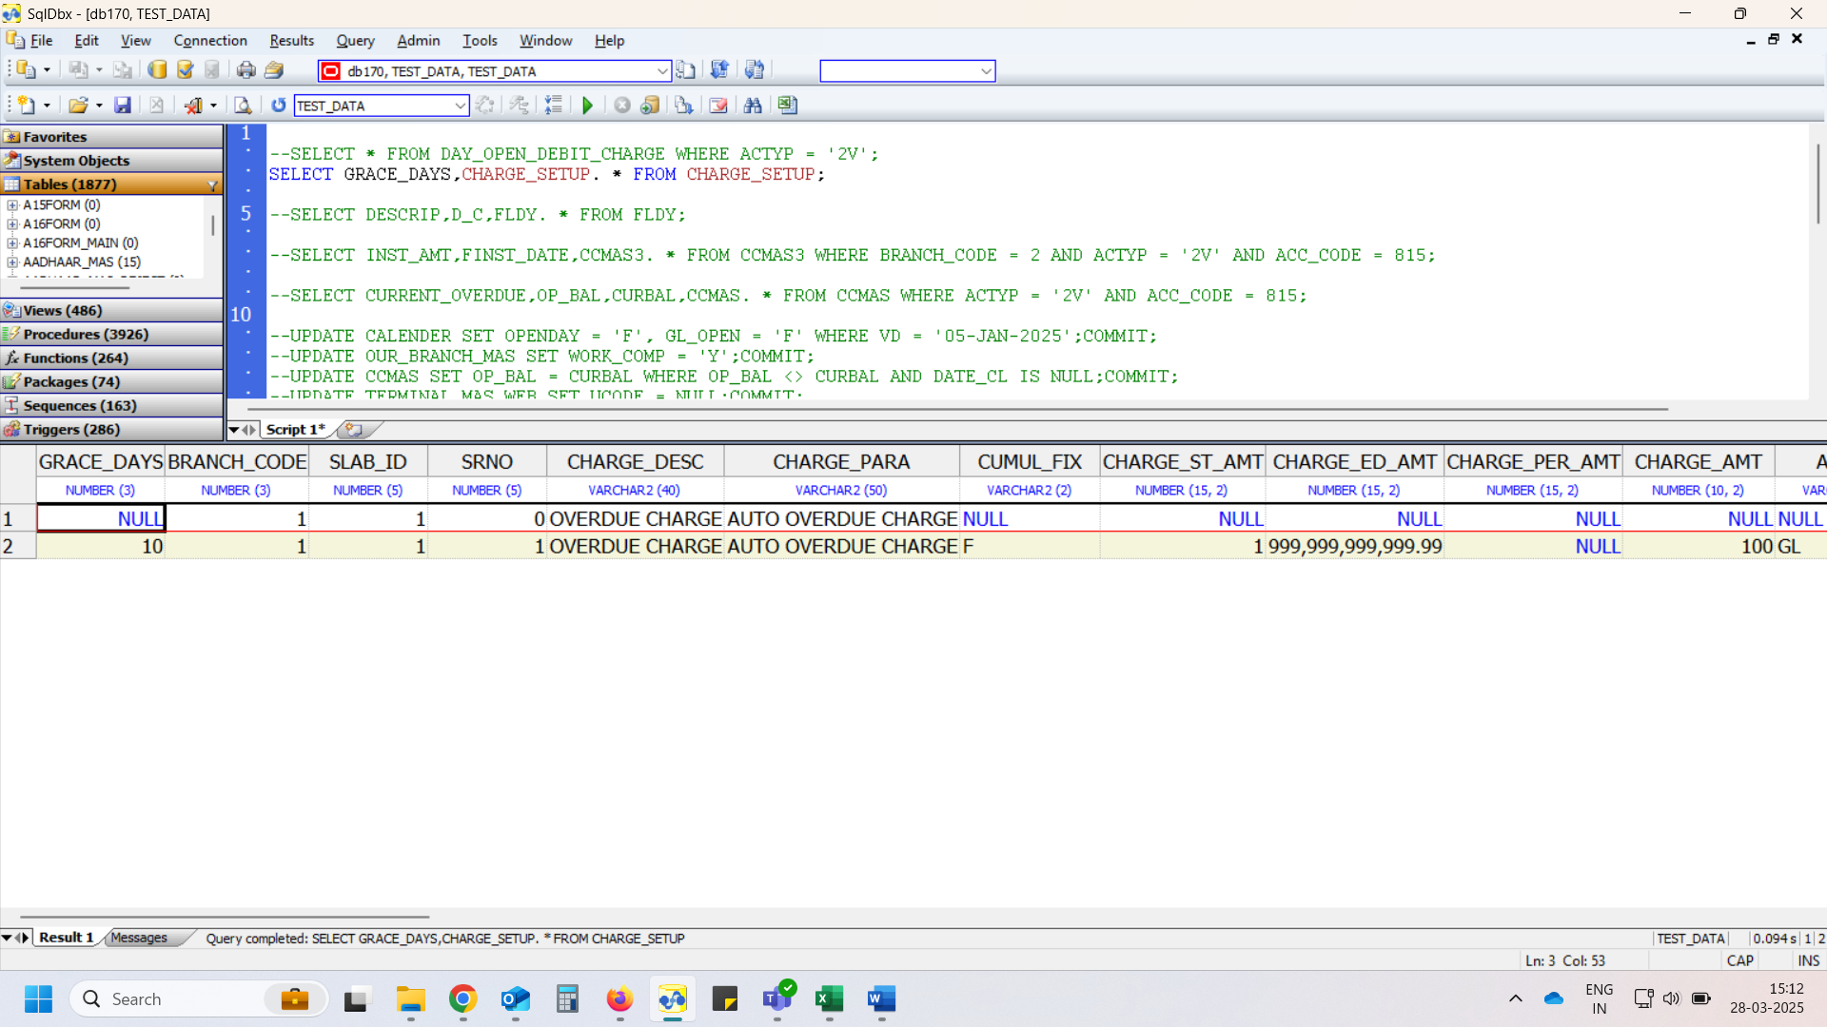

# CCMAS3

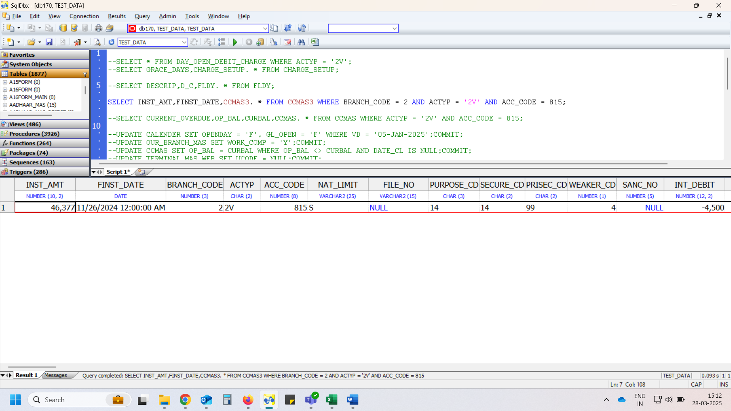

# CCMAS

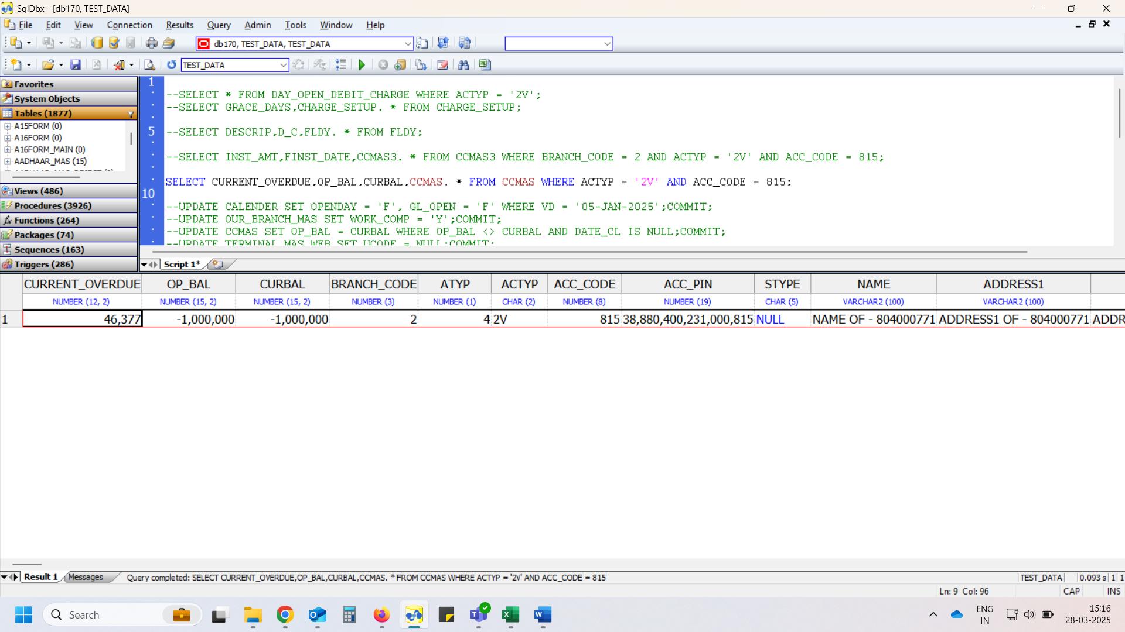

# Day Open

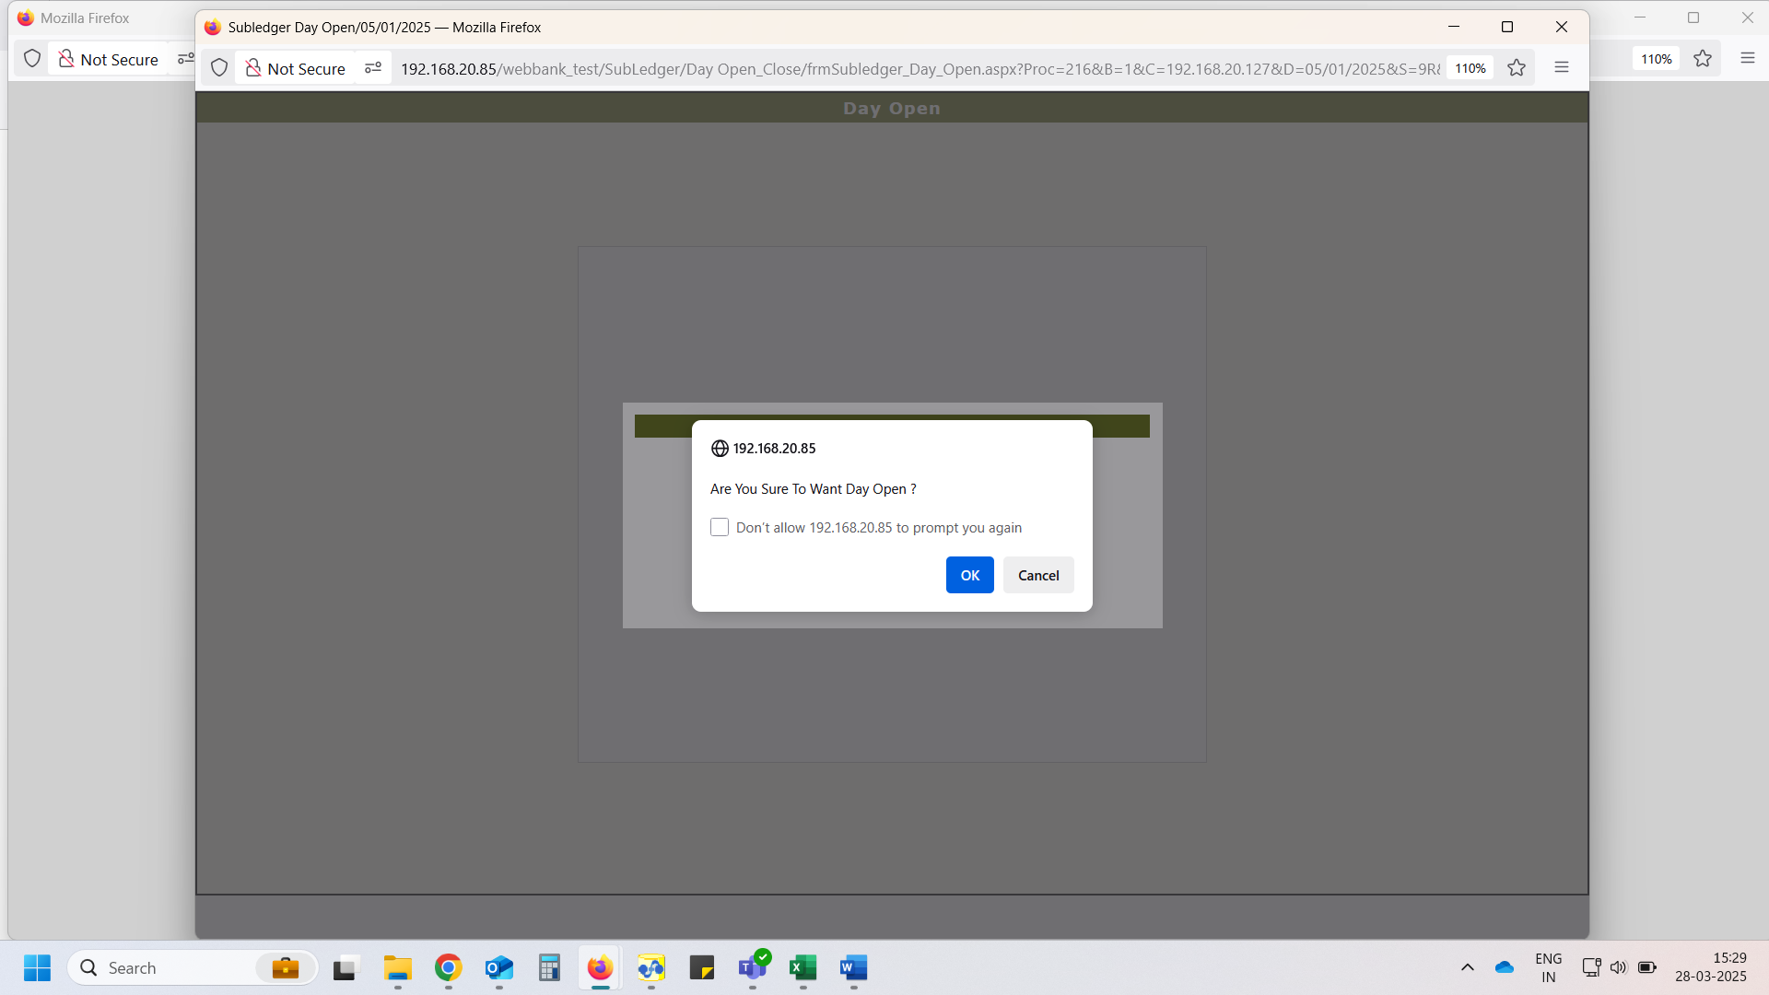

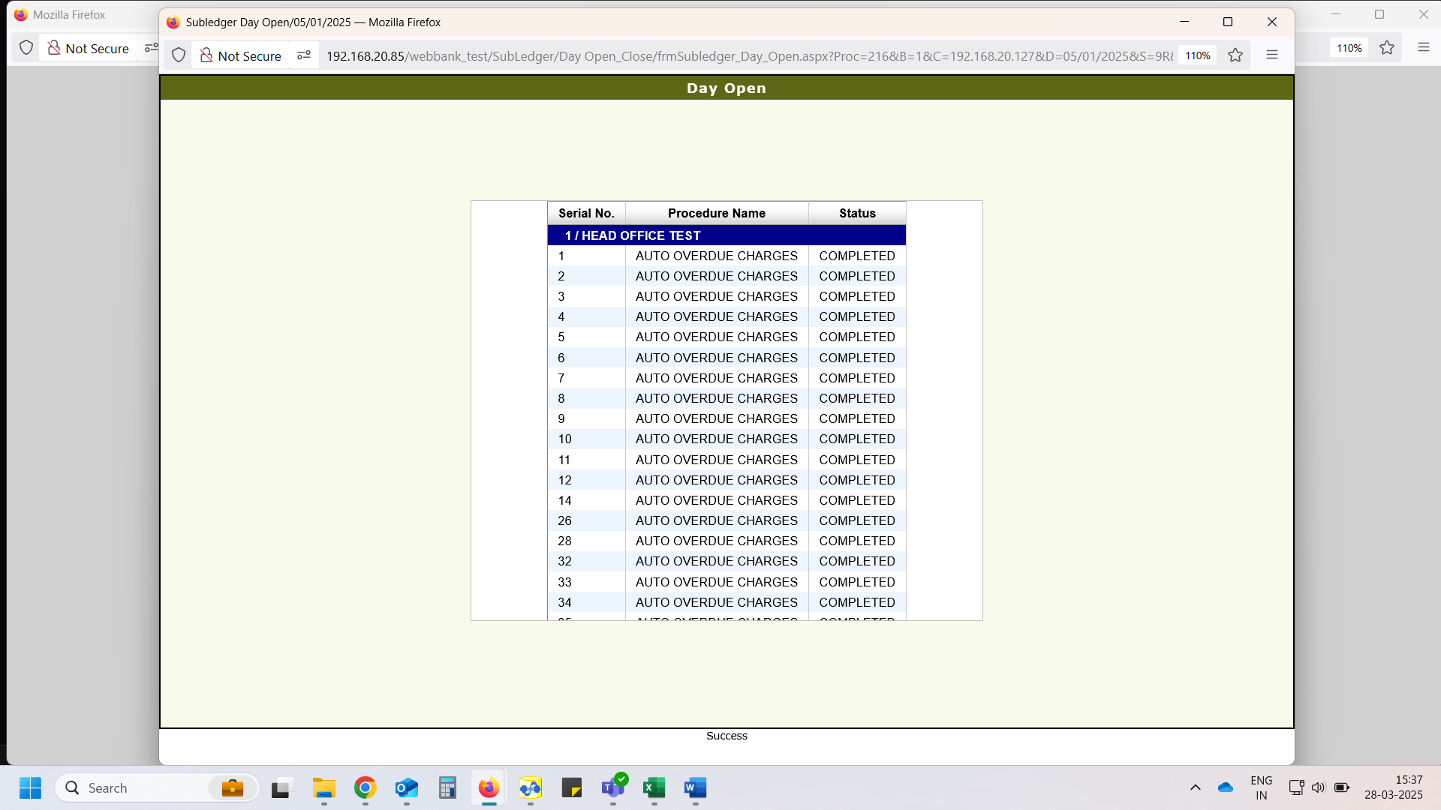

# DAY_OPEN_DEBIT_CHARGE – Charges entry does not insert, and it was issue

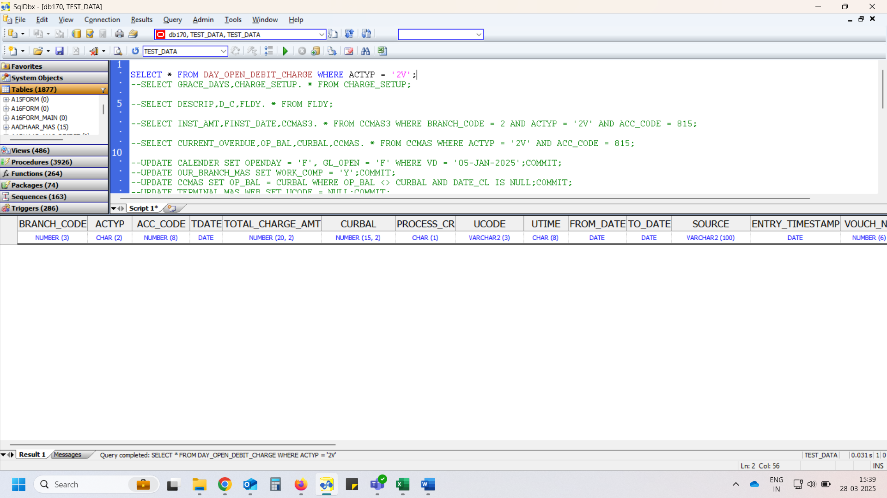

# FLDY – Charges does not debit, that was issue

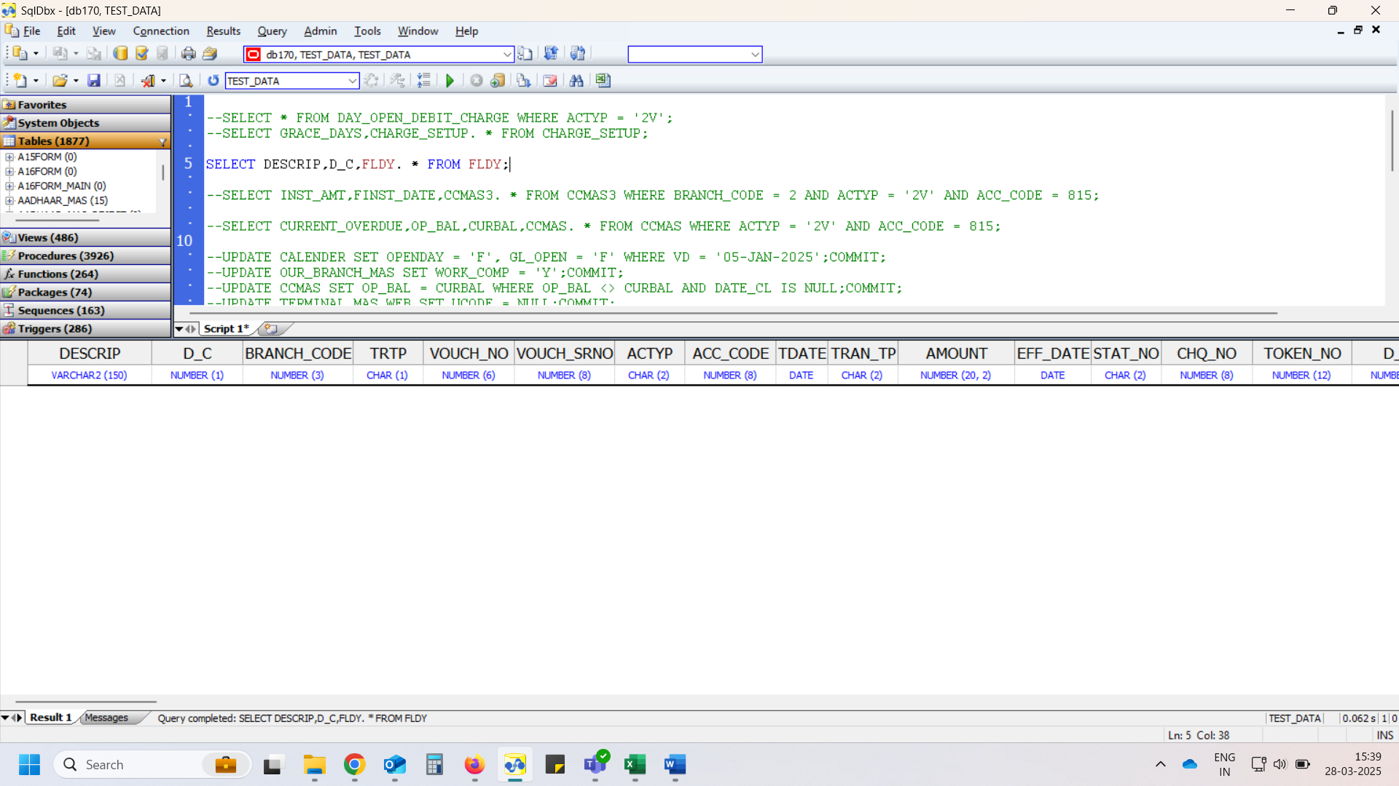

* Same scenario check after issue resolved

# DAY_OPEN_DEBIT_CHARGE

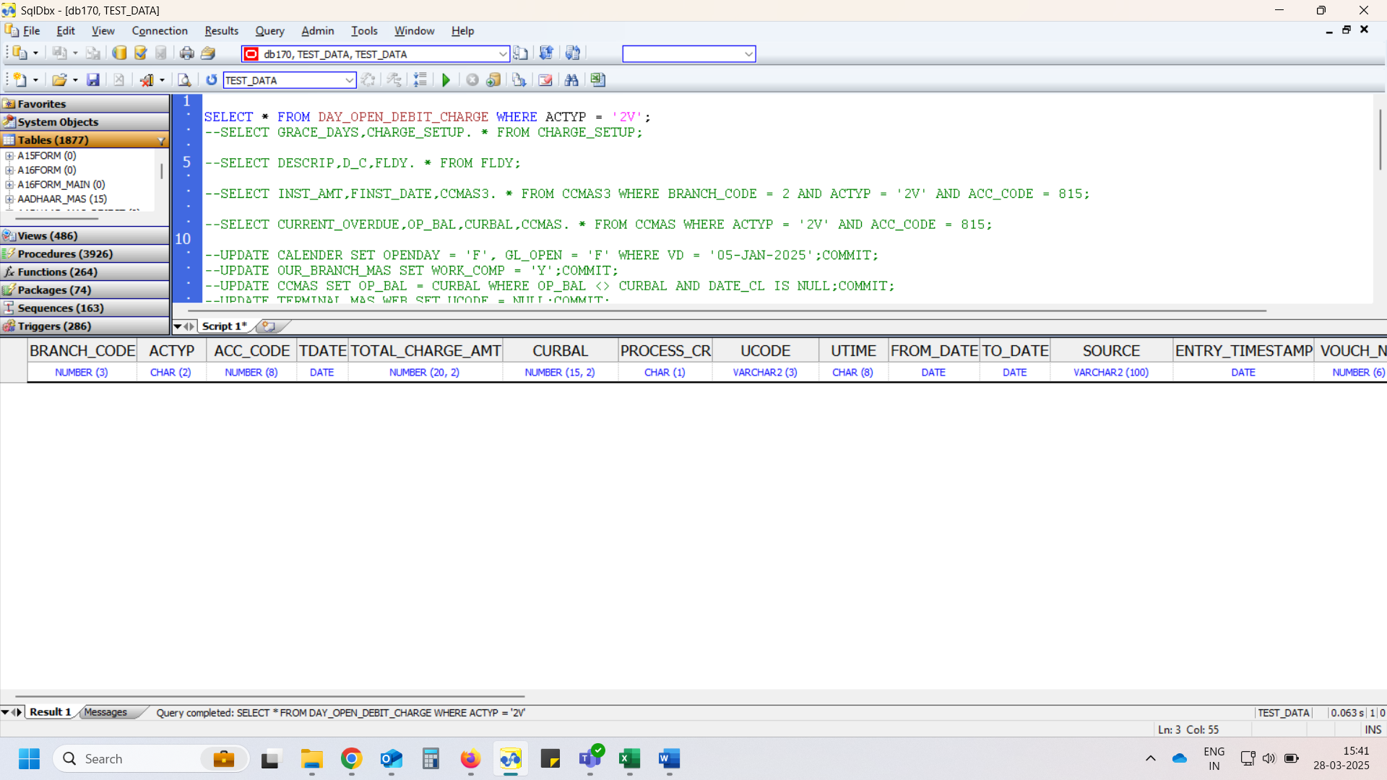

# CHARGE_SETUP

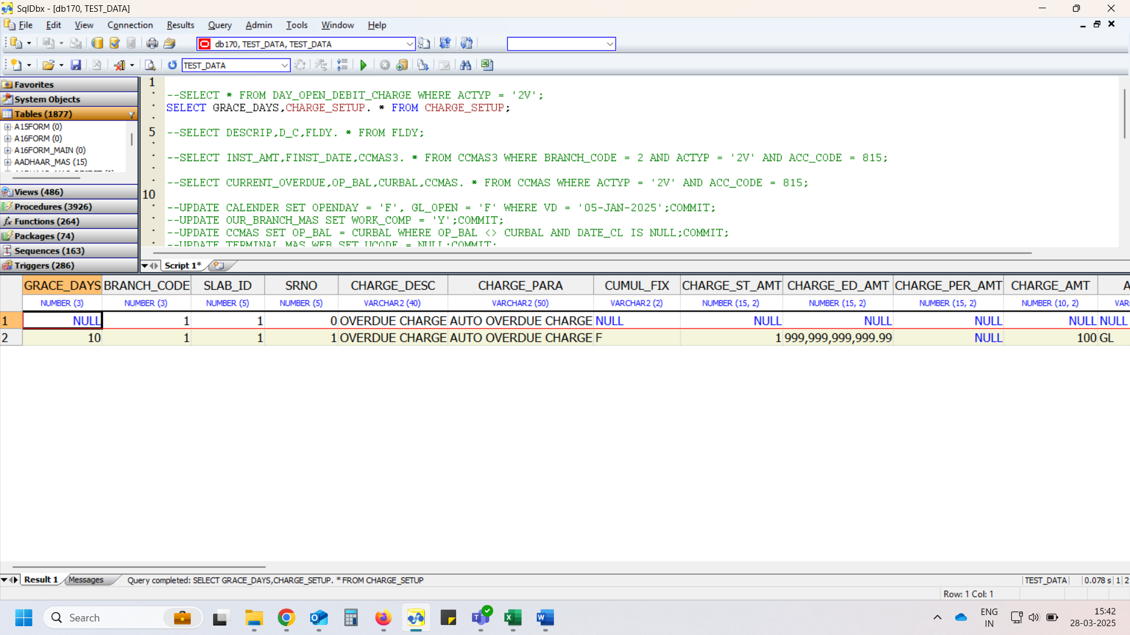

# CCMAS3

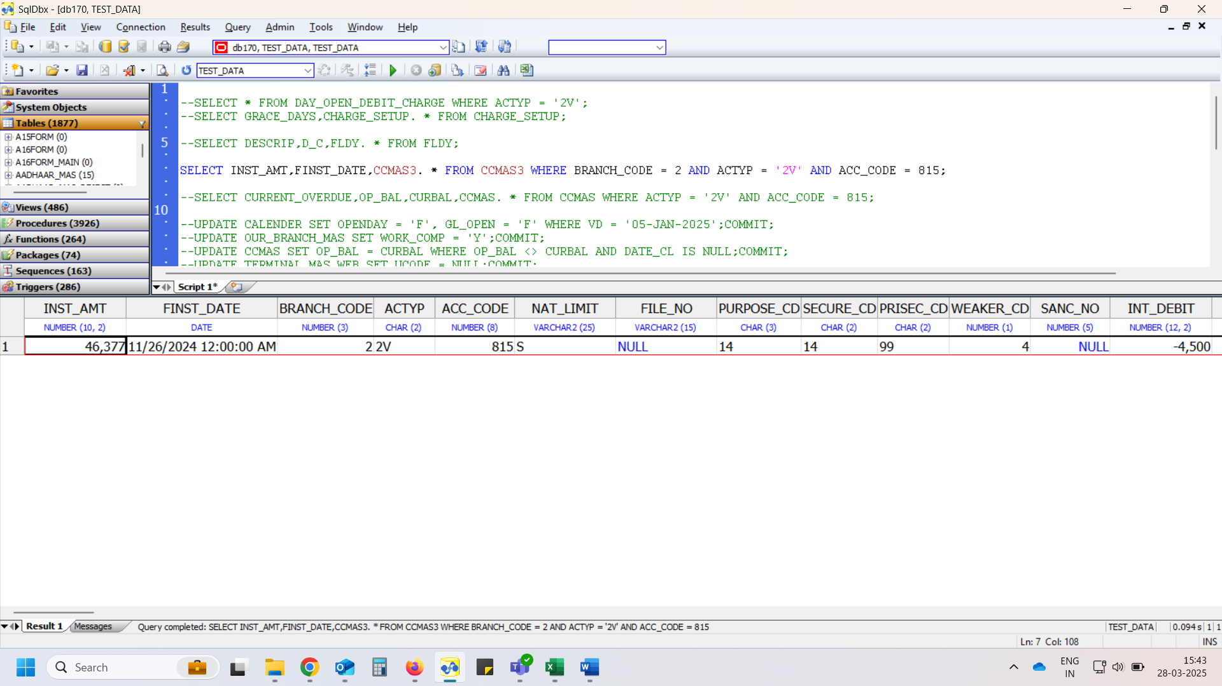

# CCMAS

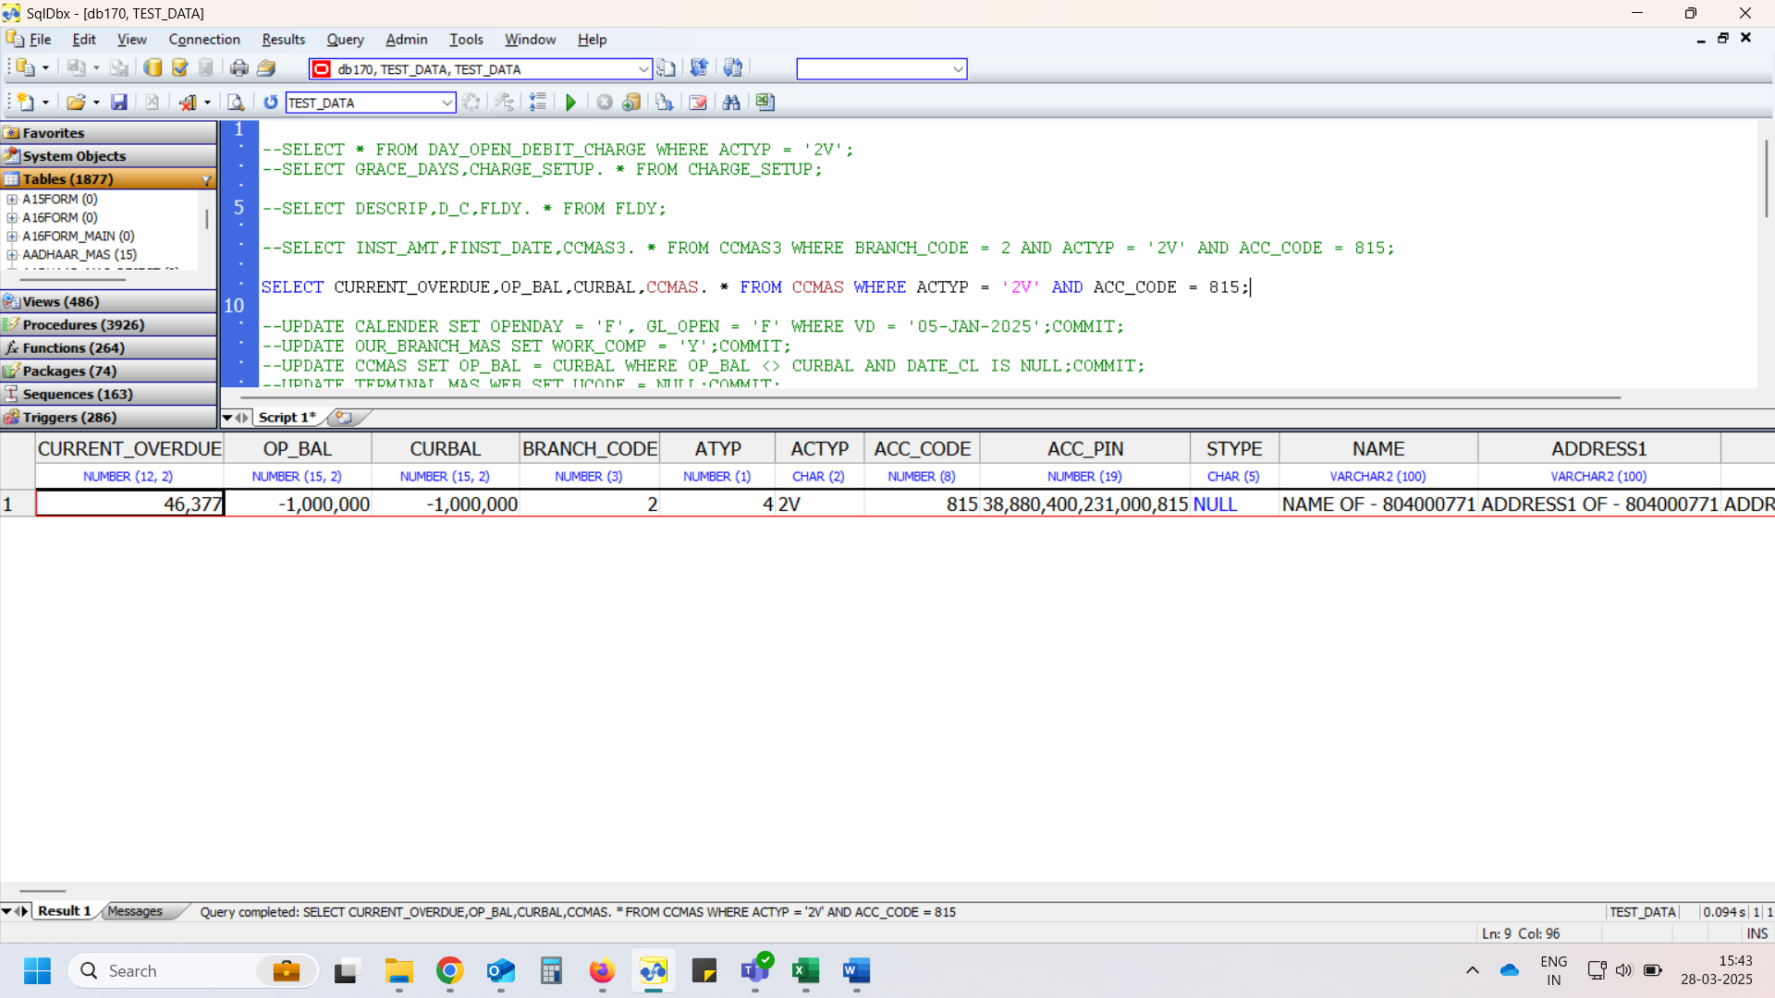

# Day Open

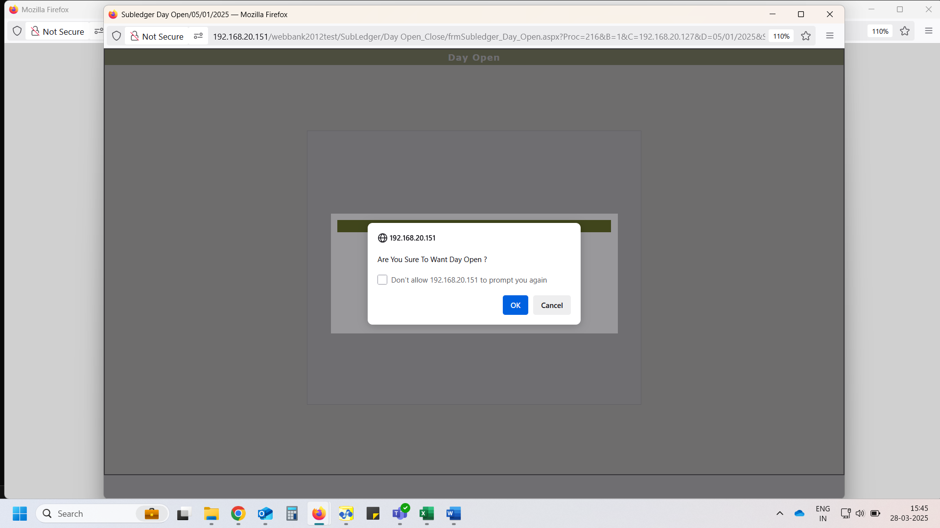

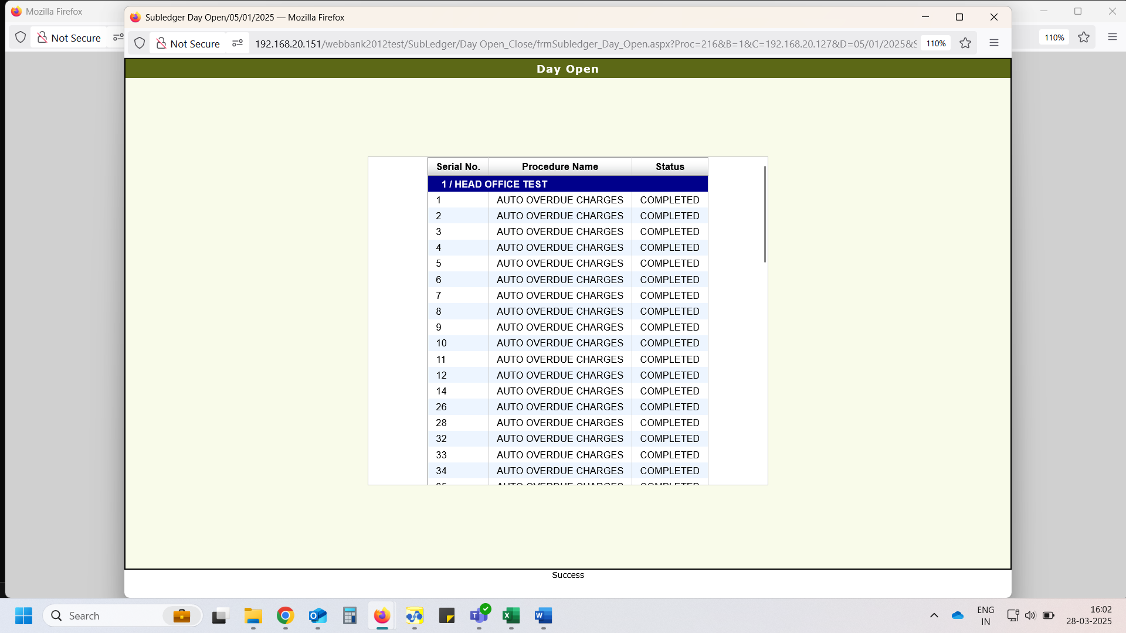

# DAY_OPEN_DEBIT_CHARGE

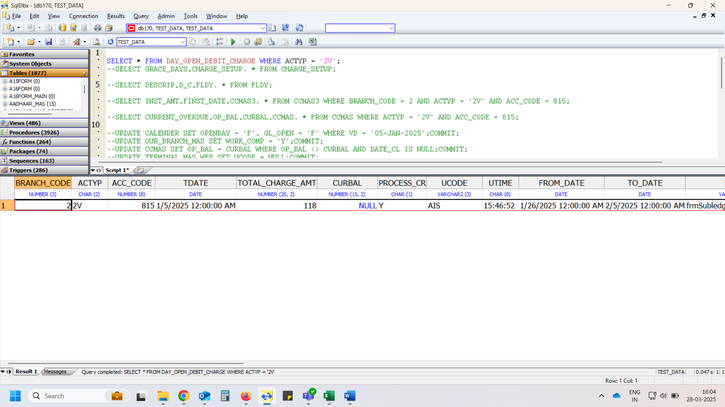

# FLDY

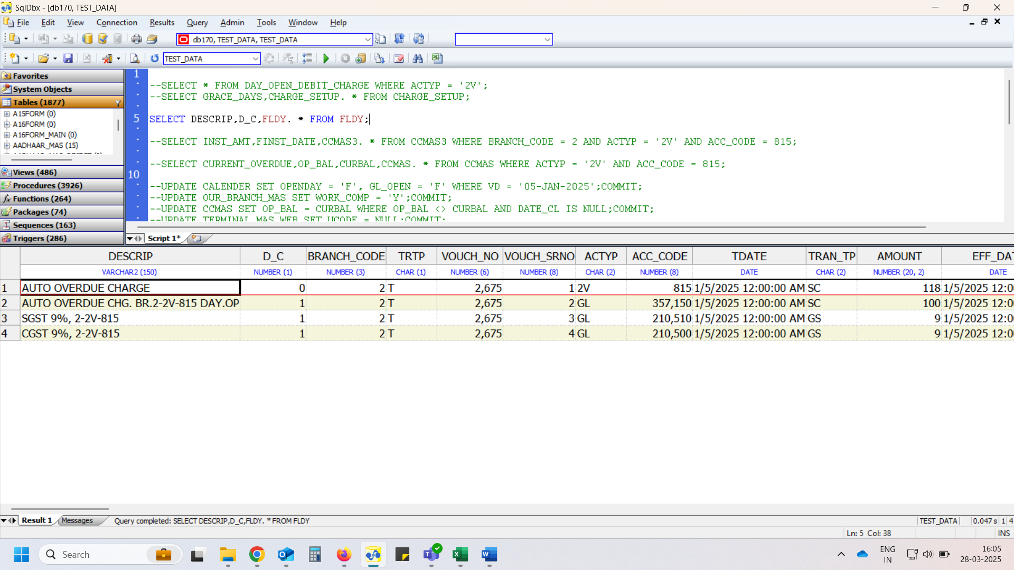

* All scenarios with test result summary which are checked

